**FOR CLIENTS AND TRAINERS**

Contents

Invalid email address entered 1

Valid email address entered 2

Password reset email received in mail 3

Following the link and entering new password 4

New password results in access 5

# Invalid email address entered

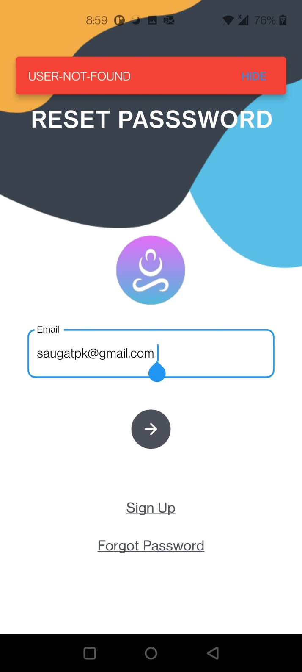

# Valid email address entered

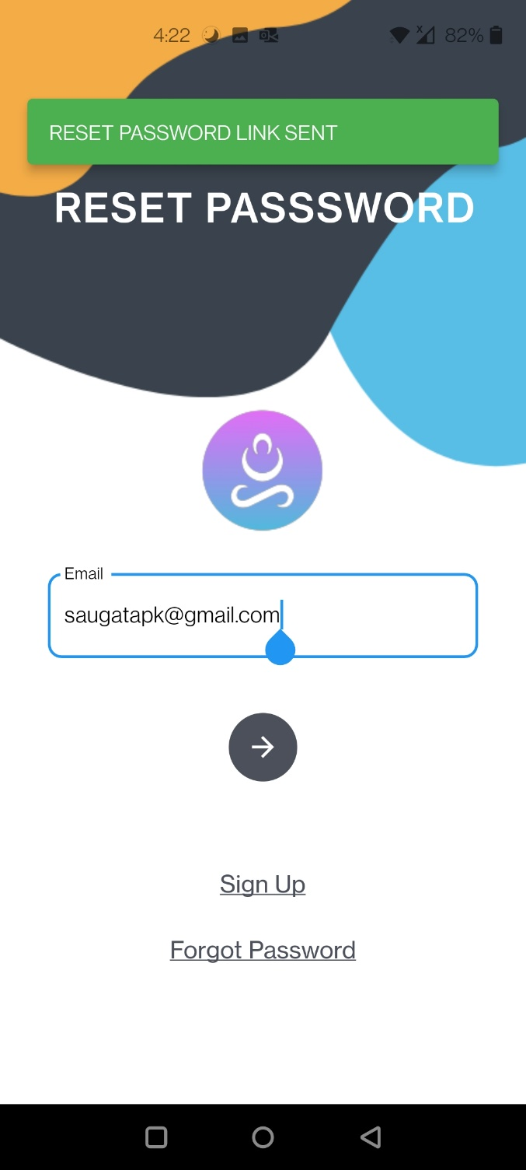

# Password reset email received in mail

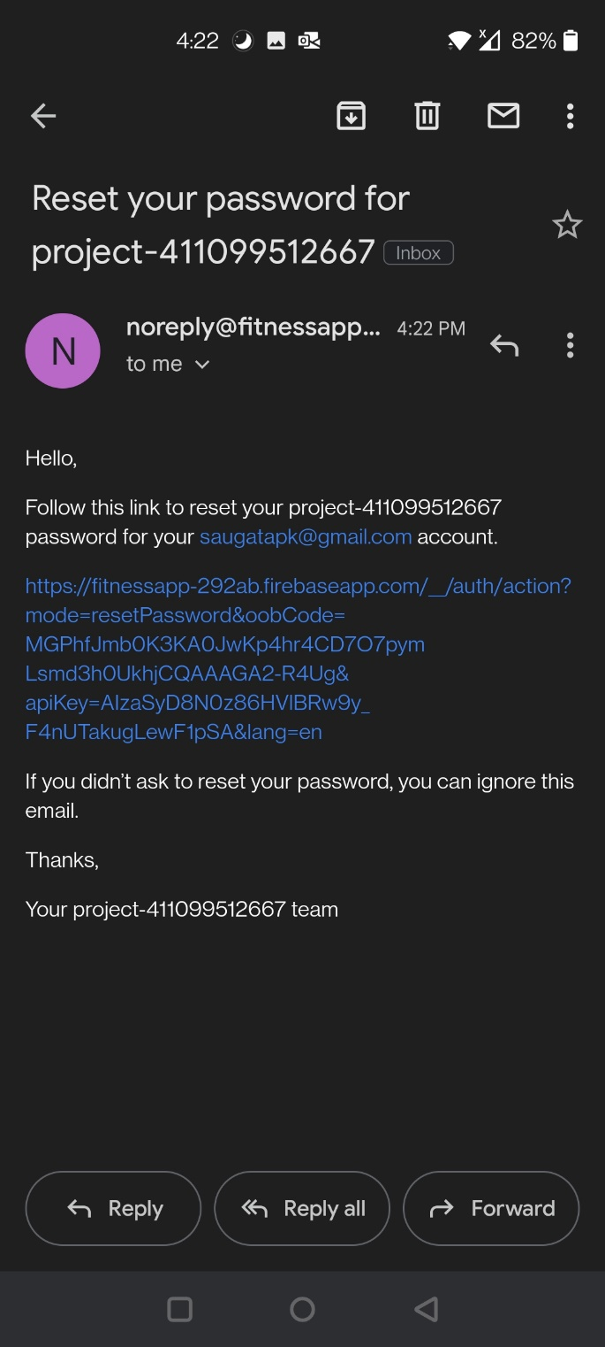

# Following the link and entering new password

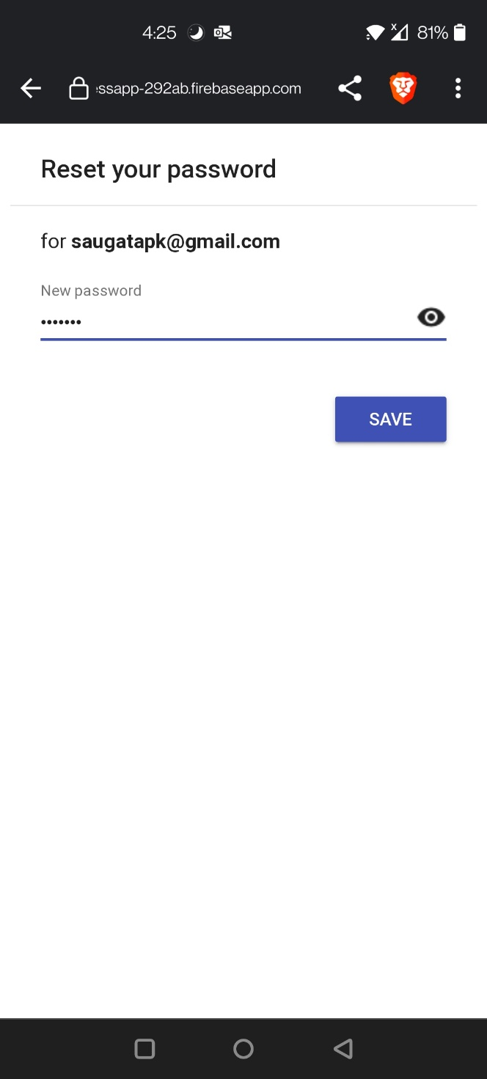

# New password results in access

